Spaceship Titanic Prediction (Task-02)

Project Overview
This project focuses on the Spaceship Titanic competition, where the goal is to predict which passengers were transported to an alternate dimension during a collision with a spacetime anomaly. By using passenger data such as home planet, age, and spending, we implement a Random Forest Regressor to determine the likelihood of transport.

Student Information
Name: Muhammad Ahmad
Roll No: 114
Task: 01 (Predictive Analytics)

Model Features
The model utilizes specific passenger metrics to make predictions:
LotArea & 1stFlrSF: Representing spatial dimensions and passenger distribution.
YearBuilt: Providing historical context of the spaceship's components.
FullBath & BedroomAbvGr: Indicators of cabin size and luxury status.
TotRmsAbvGrd: Total room count used to estimate passenger density.

Implementation Workflow
Data Loading: Utilized the pandas library to import train.csv and test.csv.
Data Splitting: Applied train_test_split to create a validation set with a fixed random_state for reproducibility.
Model Training: Configured a RandomForestRegressor with 100 estimators to ensure robust decision-making.
Error Calculation: Used Mean Absolute Error (MAE) to quantify the difference between predicted and actual values.
Output Generation: Exported the final results to submission.csv for competition entry.
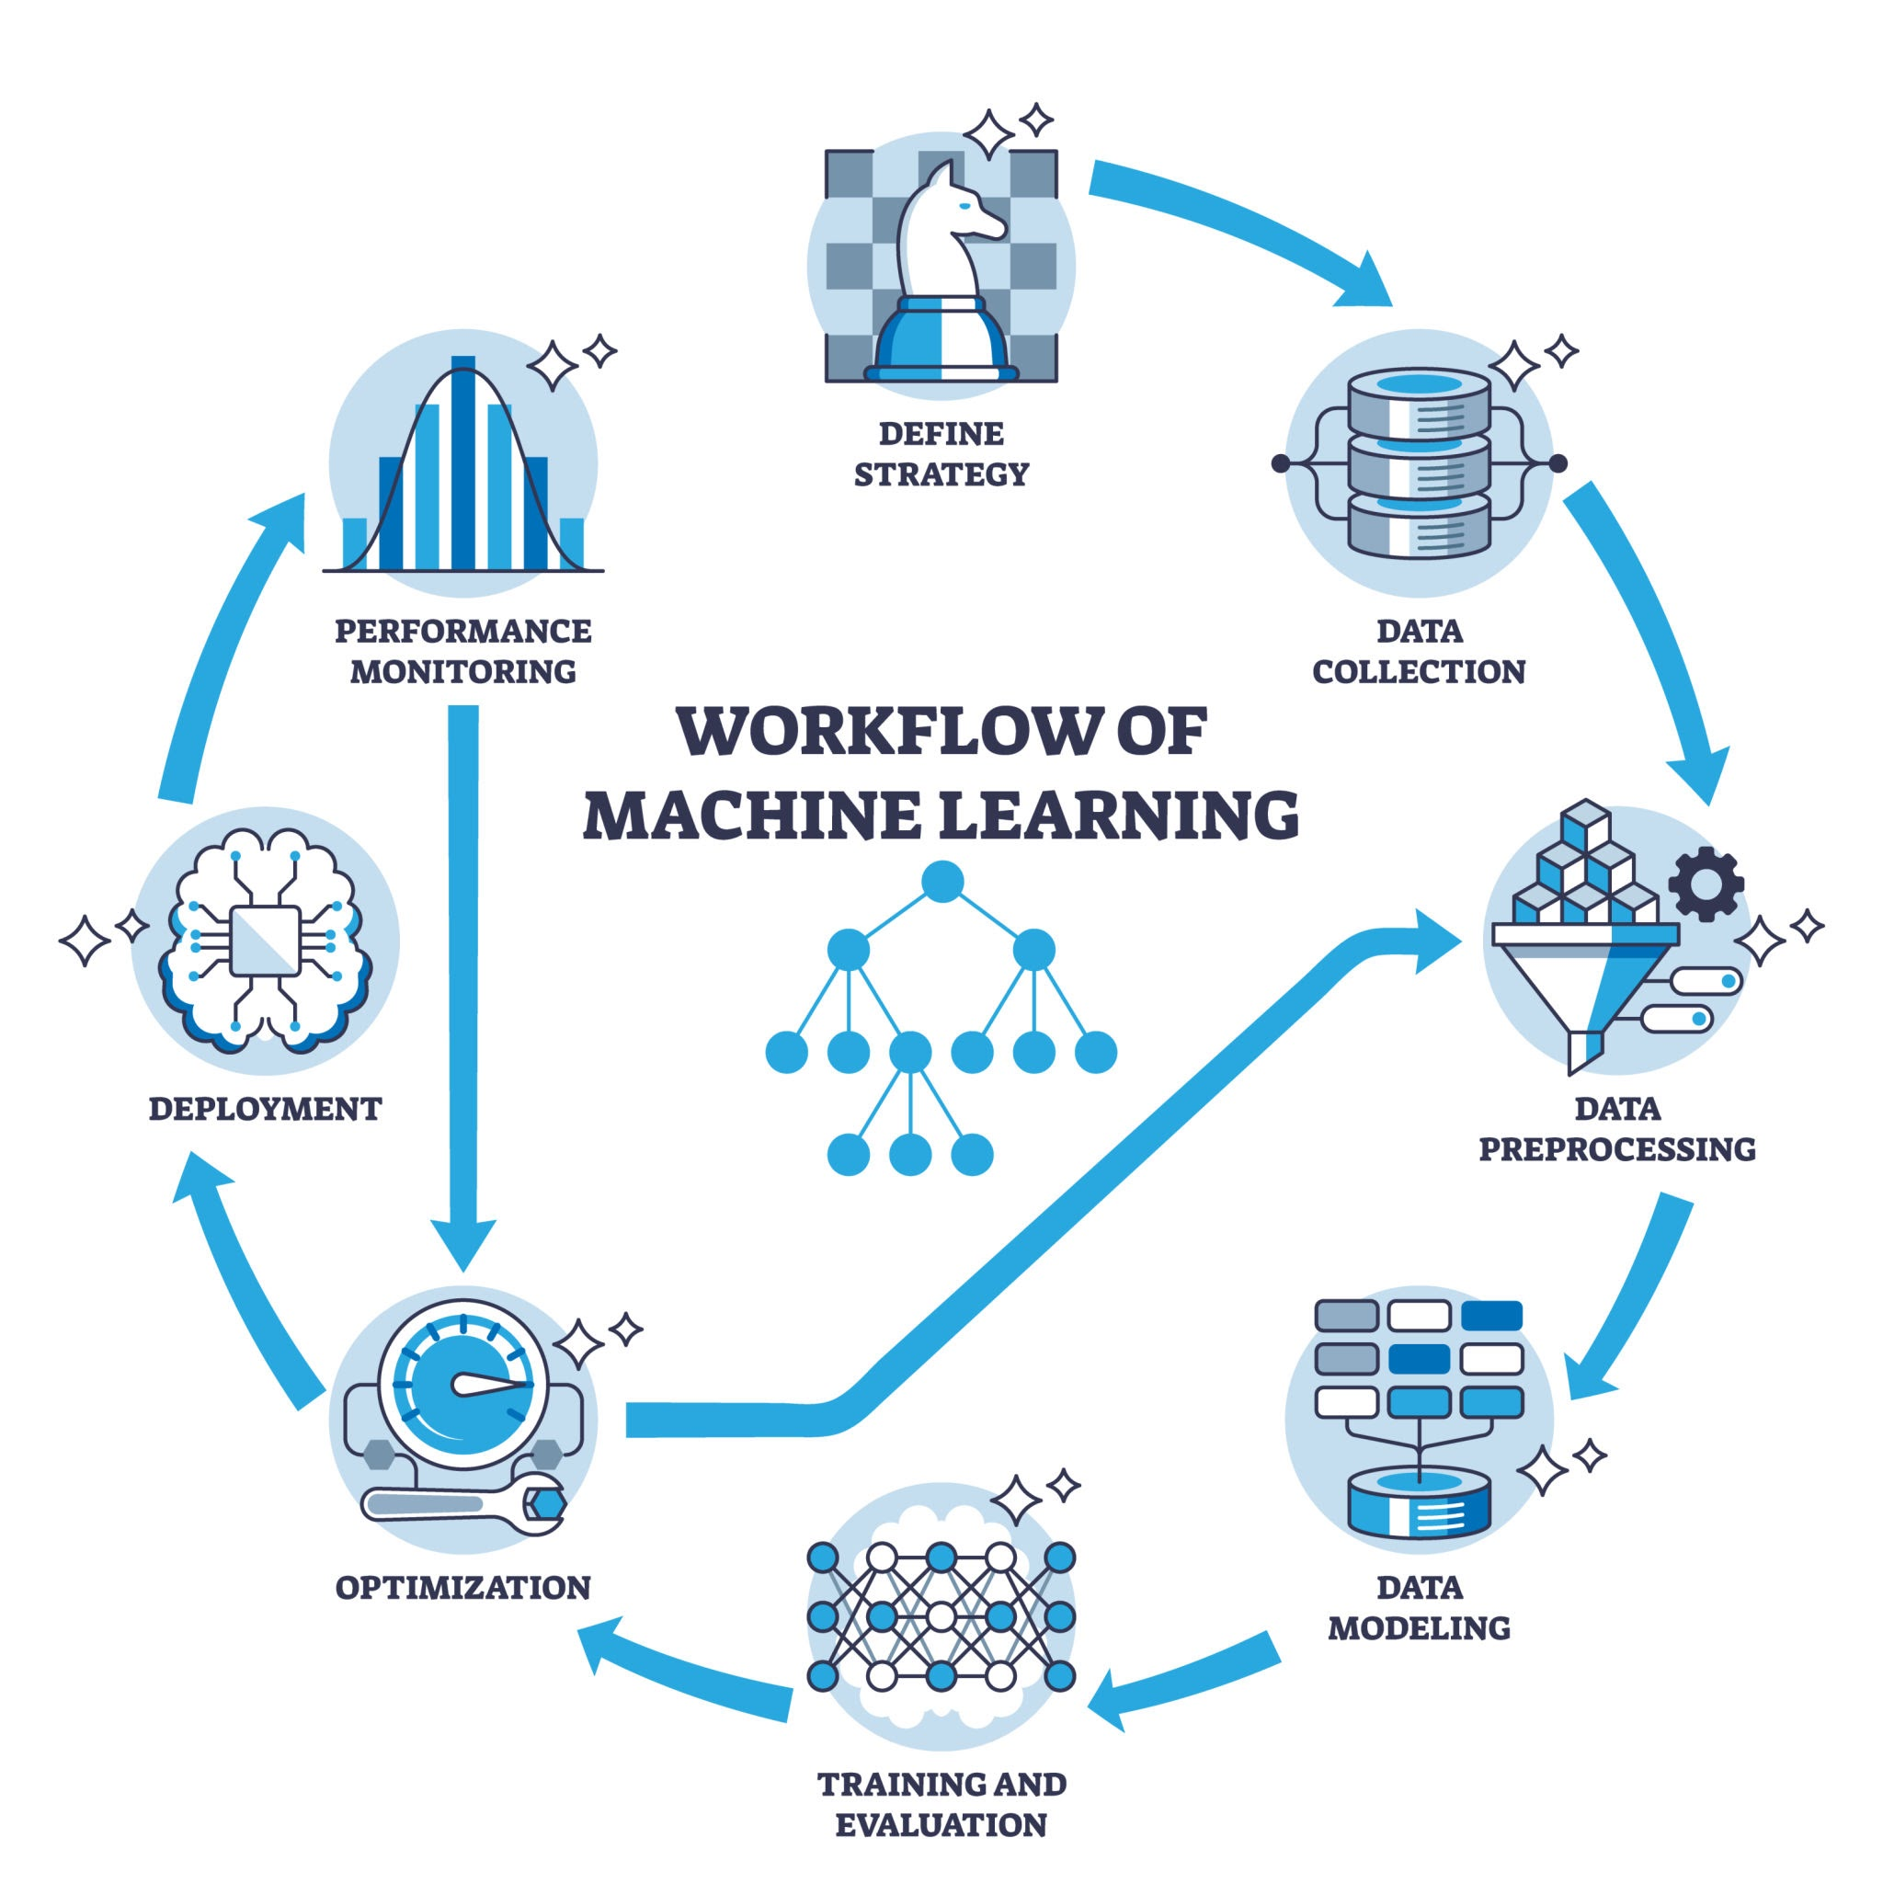

Performance Metrics
According to the latest execution results:
Validation Mean Absolute Error: $21,857.16
Status: Submission file saved successfully.

How to Run
Ensure you have the required datasets (train.csv and test.csv) in the project directory.
Run the cells in the Spaceship.ipynb notebook to train the model.
Review the submission.csv file generated in the root folder for final predictions.

